Mendocino Farms Expands Hoofprint in Seattle Area with New Kirkland Restaurant
Third Seattle location opens Oct. 29 in The Village at Totem Lake

Seattle, Oct. 15, 2024

Mendocino Farms, the fast-casual restaurant known for turning sandwiches, salads and more into an unexpected culinary adventure, is opening its third Seattle-area location in Kirkland (12540 120th Ave NE, Suite 102) on Tuesday, Oct. 29.

Located within The Village at Totem Lake, which features retail stores, a state-of-the-art cinema, office spaces and residences, the newest Mendocino Farms restaurant will introduce the brand’s “Eat Happy” ethos and adventurous flavors to the vibrant Eastside community.
“We are humbled and grateful for the overwhelming welcome we received from Seattleites at our first two locations in South Lake Union and Rainier Square, and we’re thrilled to bring another location to the area at The Village at Totem Lake in Kirkland,” said Kevin Miles, CEO of Mendocino Farms. “We are excited to become a part of the Kirkland community and hope they will enjoy our cheffy, high-quality dishes that Seattle residents have come to know and love. With this latest opening in Kirkland, we look forward to continued growth in the greater Seattle region.”

Mendocino Farms plans to celebrate their newest restaurant through a series of activations in the surrounding neighborhood, with guests invited to enjoy free food, giveaways and more.

To learn more about Mendocino Farms Kirkland, click here.

🥳 Celebrating with the Community Seattleites can join the Kirkland location’s grand opening festivities, including:
- A free entrée offer for guests who create a My Mendo account and select “Seattle-Kirkland” as their favorite location prior to opening day.
- A curated “Happy Place" event to be held on Nov. 2 from 2 p.m. to 4 p.m. with samples from Mendo, a balloon artist, face painting and limited-edition swag giveaways.
- Custom Seattle-themed tote bags filled with goodies from local favorites Kitchen & Market, Salt & Straw and Solid Core for the first 100 guests in line on grand opening day.

😋 Food for any Mood Mendocino Farms’ culinary team draws on fresh, from-the-earth ingredients to create unique, adventurous takes on sandwiches, salads and more.

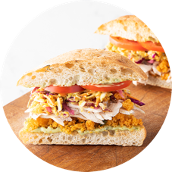
“Not So Fried” Chicken Sandwich: Mendo’s most popular entrée reimagines the classic fried chicken sandwich with a lighter, yet satisfyingly crunchy twist. Crafted with shaved, roasted chicken breast and topped with Mendo’s signature Krispies, herb aioli, mustard pickle slaw, tomatoes, and pickled red onions, this sandwich comes on toasted ciabatta and is served with a side of tangy mustard barbecue sauce or mustard pickle remoulade.

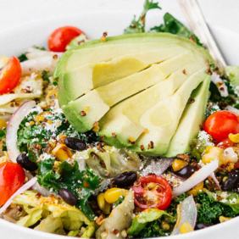
Avocado & Quinoa Superfood Ensalada: Packed with crisp chopped romaine, hearty curly kale, and a blend of quinoa and millet, this salad is loaded with Mendo’s house made superfood krunchies, a zesty succotash with roasted corn, black beans, and jicama, plus tangy red onions, fresh cilantro and creamy cotija cheese. Topped with grape tomatoes, avocado and finished with a chipotle vinaigrette, it’s a crave-worthy mix of flavors and textures in every bite.
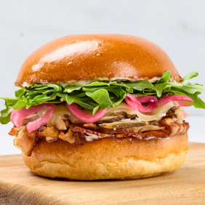
Black Tie Turkey Club: Mendo’s limited-time Black Tie Turkey Club elevates the classic club sandwich with roasted turkey, applewood smoked bacon, white cheddar cheese, pickled red onions, arugula and truffle mustard aioli, all served on a lightly toasted brioche bun.

In addition to their refreshing housemade beverages, Mendocino Farms Kirkland will also have beer and wine on tap, with local beer offerings from Fremont Brewing Company, Georgetown Brewing Company and Silver City Brewery.

🍴How to “Eat Happy” Mendocino Farms Kirkland will be open for dine-in, pick-up or delivery daily from 11a.m. to 9 p.m. Guests can order ahead through the Mendocino Farms website or app, or via Uber Eats, DoorDash and Postmates.

The community can also fuel their gatherings with Mendo’s new catering menu, which includes offerings such as the Meat & Cheese Platter and the Veggies & Dips Platter. Catering orders can be placed online or by calling the restaurant, where a dedicated catering team is ready to assist.

About Mendocino Farms
Mendocino Farms takes guests on a culinary adventure with its diverse menu of chef-driven, seasonal sandwiches and salads made from fresh, high-quality ingredients. Founded in Southern California in 2005 by husband-and-wife team Mario Del Pero and Ellen Chen, Mendocino Farms has grown to 71 locations and counting in California, Texas and Washington. By creating gathering places for connection and nourishment whether dining in store, enjoying at home, or catering to the office, the restaurant company aims to make hearts and stomachs happy through unexpected flavors and friendliness. For more information visit mendocinofarms.com

For more information, contact:

Daina Rama
Jackson Spalding on behalf of Mendocino Farms
MendoPR@JacksonSpalding.com
404.214.3699
###

